Reconstruction of the “Terfener Innbrücke” bridge on the A12 motorway in Austria’s Inntal valley

Terfener Innbrücke, Terfens, Austria
The Terfener Innbrücke reconstruction project on the A12 motorway in the Inntal valley is one of largest bridge construction projects currently being carried out in the west of Austria. With PERI by their side, the client has been successful in implementing the project according to the demanding construction schedule since construction began in 2018. In addition to providing comprehensive planning services and on-site support during the project, PERI has also made use of the VBC Balanced Cantilever Carriage for the first time in Central Europe.
The A12 motorway winds its way through the heart of the Austrian federal state of Tyrol for around 153 km, starting at Kiefersfelden/Kufstein at the German-Austrian border and passing the city of Innsbruck on its way towards the municipality of Zams. The motorway cuts through the Inntal valley, which provides the backdrop for the Inntalbrücke, a bridge measuring roughly 235 m in length. Every day, approximately 60,000 vehicles use this bridge to get from one side of the Inn river to the other. For reasons of efficiency and safety, reconstruction of the bridge began in 2018 with a strict construction time frame of three years. The project will see the two existing steel composite bridges replaced by two new bridge support structures made of pre-stressed concrete.

Comprehensive solution from a single source
The project was implemented using the cantilever construction method. This bridge construction process, which is carried out according to the beam principle, sees the superstructure erected in relatively short sections starting from the piers, using a cantilever carriage. PERI engineers assumed responsibility for the project-specific planning process and the static calculations for the balanced cantilever carriage. By using the VBC Balanced Cantilever Carriage including formwork, PERI was able to provide the client with a tailor-made, comprehensive solution – from the planning phase right through to the final product and even on-site support. This meant that all of the systems and processes were optimally coordinated, thereby minimising potential sources of error and interface losses.

A cost-effective comprehensive solution
Considering the fact they are based on the VARIOKIT Engineering Construction Kit, the rentable system components of the VBC Balanced Cantilever Carriage could be made available at short notice. The first delivery of materials took place in January 2019. The first concreting process was carried out only two months later.
The decision to use the VBC Balanced Cantilever Carriage meant that 5.70-m-long concreting sections could be realised. This resulted in a reduction of only four cycles per bridge support structure: a total of eight during the project. The fact that the system is highly flexible and easy to align meant that the respective segments could be concreted in weekly cycles. What's more, the fully integrated hydraulic unit simplified the process of adjusting and calibrating the formwork from one section to the next. Given the fact it is convenient to operate, the system could be moved to the next cycle quickly and easily.

A clever system for balanced cantilever construction
All in all, the complexity of this project was considerable. With this in mind, the VBC Balanced Cantilever Carriage proved extremely useful due to the fact that it could be adapted flexibly to specific requirements on the construction site. For example, the presence of the longitudinal cantilevered slab retaining wall in the area of the abutment, which runs from the upper edge of the foundation up to the lower edge of the cantilevered slab, meant that it was necessary to alter the projection of the cross girders in the grate and to have a supporting structure spacing of only 50 cm.
The formwork carriage also proved to be advantageous when concreting the carriageway slab as its carriageway slab formwork reduced the degree of penetration in the supporting structure due to the fact it is positioned on the M24 tie sleeves. The balanced cantilever carriage was also comparatively straightforward to dismantle. The time-consuming process of lowering the rails to retract the carriages was not required.

Comprehensive support prior to and during the construction work
The construction site team and the PERI engineers have had to overcome some challenges over the course of the project. For example, the Innsbruck area, and therefore also the Terfener Innbrücke, happens to be in an earthquake zone. As such, the structural calculations used for both the bridge support structure and the balanced cantilever carriage had to allow for seismic loads in order to account for the possibility of an earthquake.
For the duration of the project, a supervisor provided the team with regular on-site support with activities such as assembling the supporting structure, operating the VBC Balanced Cantilever Carriage, switching to the next hammer head and dismantling the formwork carriage.

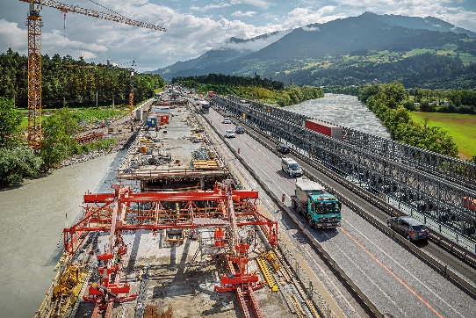 | Image 1  The Terfener Innbrücke, which measures roughly 235 m in length, is situated on the A12 motorway in the Inntal valley in Tyrol.  (Photo: Günther Bayerl)
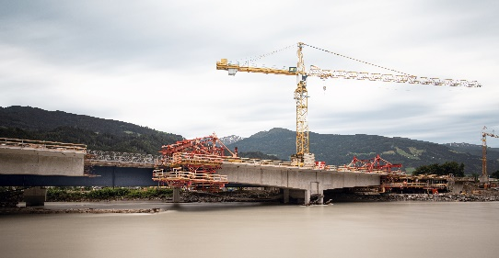 | Image 2  The project was carried out using the balanced cantilever construction method and the VBC Balanced Cantilever Carriage. The rentable system components of the VARIOKIT Engineering Construction Kit provided the basis for this.  (Photo: Günther Bayerl)
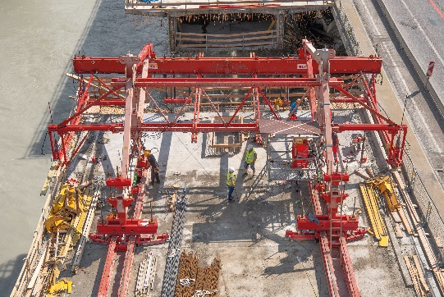 | Image 3  With the VBC Balanced Cantilever Carriage, it was possible to complete 5.70-m-long concreting sections on a weekly basis.  (Photo: Günther Bayerl)
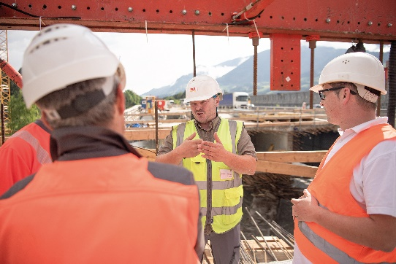 | Image 4  PERI engineers provided the construction site team with on-site support and carried out comprehensive planning and calculation work.  (Photo: Günther Bayerl)
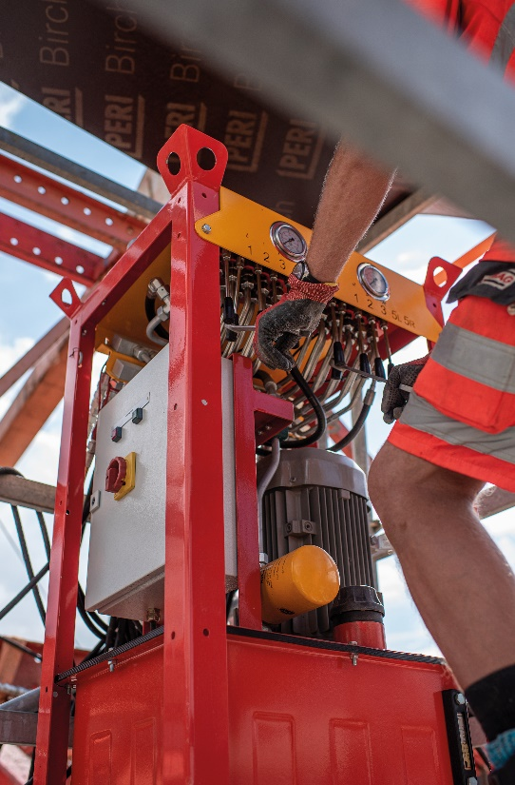 | Image 5  Given the fact it is convenient to operate, the VBC Balanced Cantilever Carriage could be moved quickly and easily to the next of a total of eight cycles.  (Photo: Günther Bayerl)
Contractor
ARGE (PORR/Strabag)
Project coordination
PERI Austria

